EEE 120
Lab 3 Answer Sheet
Registers, Counters and the “Brainless CPU”
Name: Dylan Shah
Instructor/Time: Dr. Steve Millman Tu Th 3:00 PM - 4:15 PM Date: March 06, 2026
Task 3-1: Build and Test a 4-Bit D Register with Enable
Include a picture of your Digital circuit here:
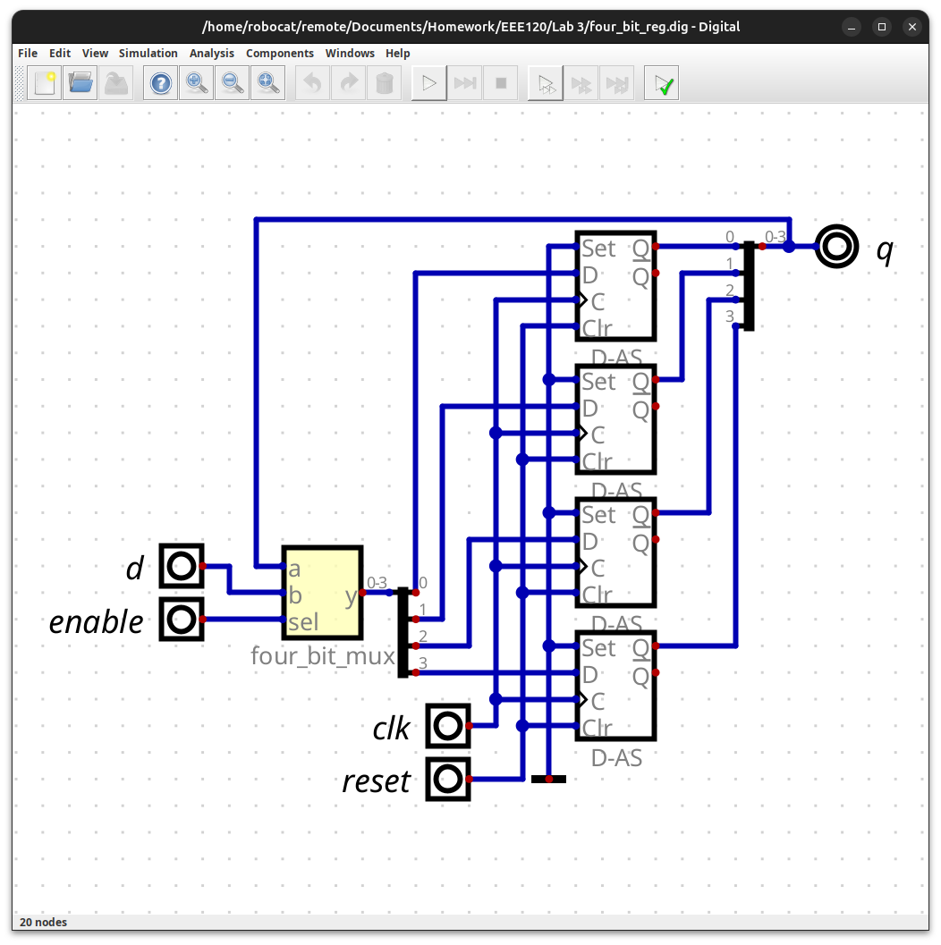
Please comment on the single biggest issue you were facing when designing the circuit.
I kept forgetting to set `d` and `q` to four-bit, and then digital kept complaining.
Include a picture of your GTKWave waveforms (timing diagram) here:
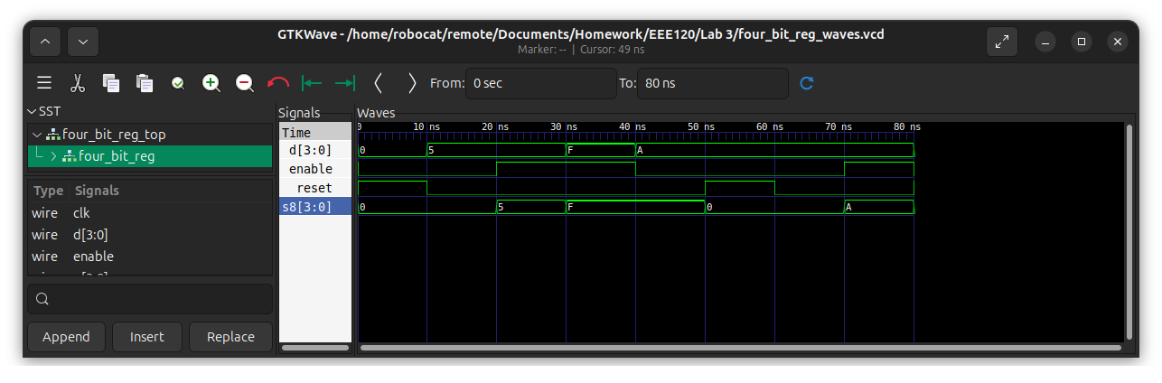
Did the circuit behave as expected? If no, what was wrong?
Yes, the circuit behaved as expected.
Please comment on the single biggest issue you were facing when simulating the circuit.
Digital was auto saving my .v file in my lab 2 folder, not lab 3.
Task 3-2: Build and Test a 4-Bit UP Counter
Include a picture of your Digital circuit here:
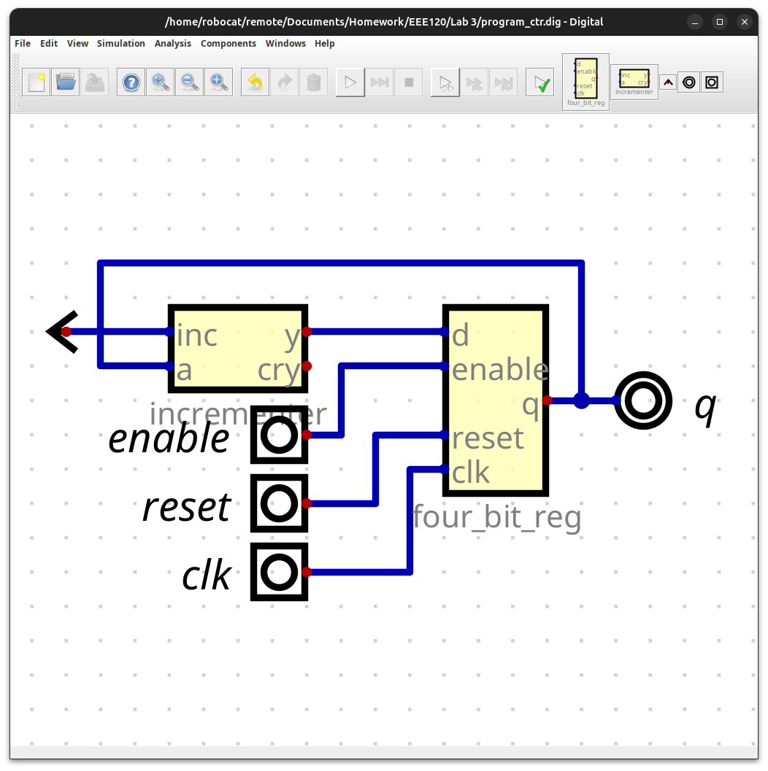
Please comment on the single biggest issue you were facing when designing the circuit.
I did not experience any issues.
Did the circuit behave as expected? If no, what was wrong?
Yes, the circuit behaved as I expected.
Please comment on the single biggest issue you were facing when simulating the circuit.
I did not experience any issues simulating the circuit.
Task 3-3: Create a 4-Bit RAM with 16 4-Bit Words
Include a picture of your Digital circuit here:
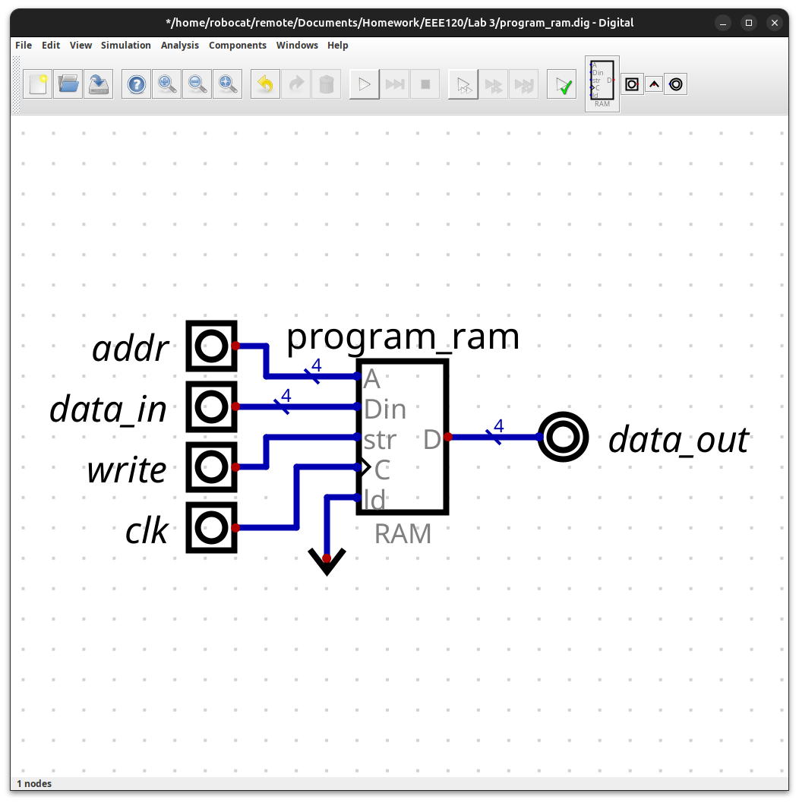
Please comment on the single biggest issue you were facing when designing the circuit.
I placed the output too close to the ram, which caused digital to crash when I opened its settings menu.
Did the circuit behave as expected? If no, what was wrong?
Yes, the circuit behaved as expected.
Please comment on the single biggest issue you were facing when simulating the circuit.
When testing a write, I put `A` in the input for data_in, forgetting that I needed to do `0xA` for digital. Once I fixed this, everything worked as expected.
Task 3-4: Build and Test the Brainless Central Processing Unit
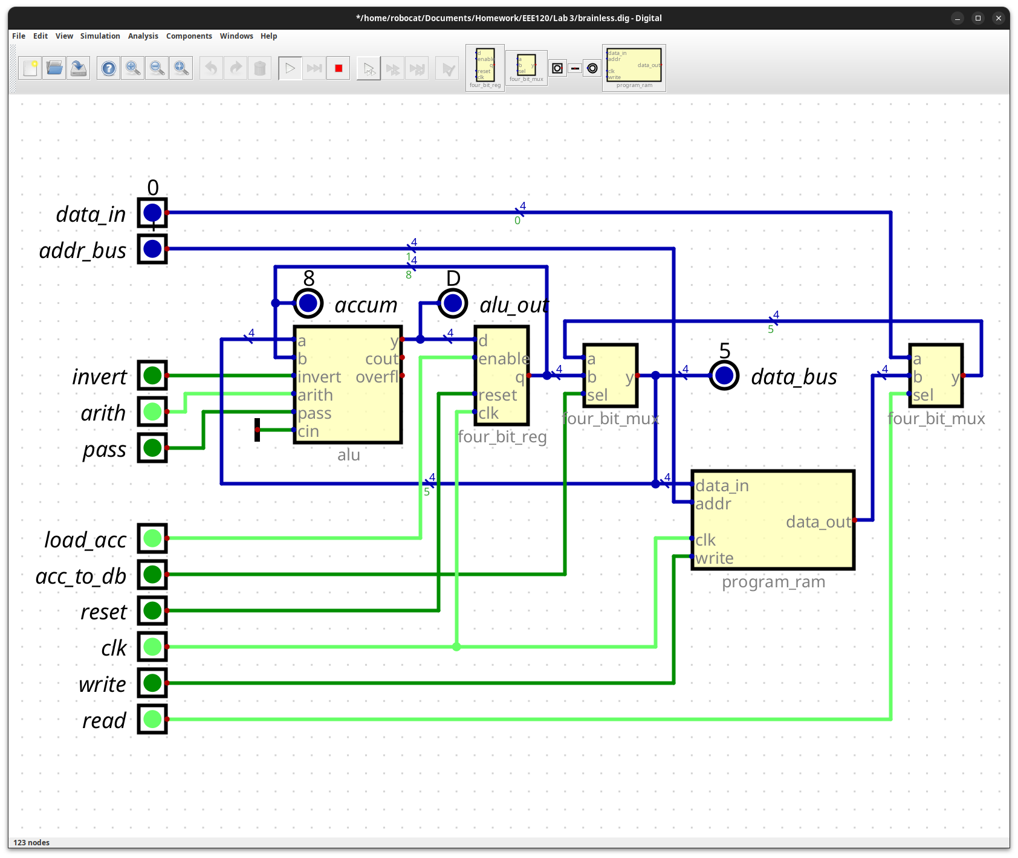
Include a picture of your Digital circuit here:
Please comment on the single biggest issue you were facing when designing the circuit.
Double checking that my circuit looks like the diagram was difficult as the wires in the center was difficult, as they are snaky and hard to visually follow.
Did the circuit behave as expected? If no, what was wrong?
Yes the circuit behaved as I expected it too.
Please comment on the single biggest issue you were facing when simulating the circuit.
I did not have any issues simulating the curcuit.
Task 3-5: Simulate the Brainless Central Processing Unit
Include a picture of your GTKWave waveforms (timing diagram) here:
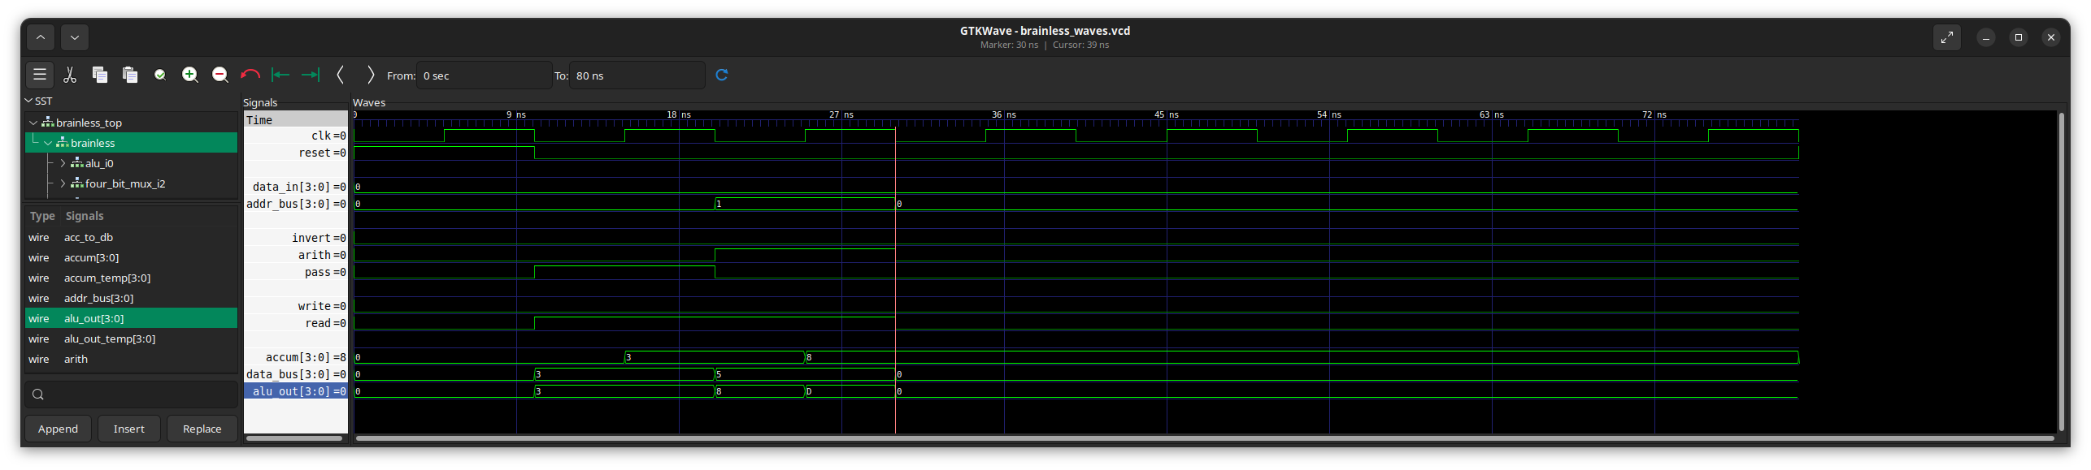
Did the circuit behave as expected? If no, what was wrong?
Yes, the circuit behaved as expected.
Please comment on the single biggest issue you were facing when simulating the circuit.
I did not experience any issues simulating the circuit.
Task 3-6: Create Additional Tests
As shown in the manual, paste the test_vals you used for each of the tests here. Be sure to note which each set of test_vals goes with each test.
External Write
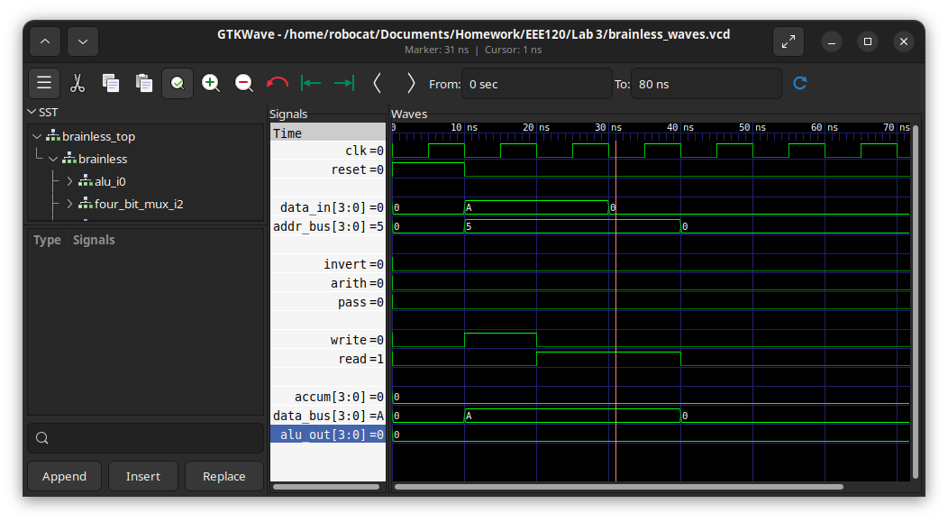
test_vals[0] = 28'h0_0_0_0_0_0_4; // reset - this should always be the first vector
test_vals[1] = 28'h0_A_0_A_5_0_2; // Store the value A at address 5
test_vals[2] = 28'h0_A_0_A_5_0_1; // Read address 5 to ensure it is A.
test_vals[3] = 28'h0_A_0_0_5_0_1; // Ensure that changing the inputs does not matter
test_vals[4] = 28'h0_0_0_0_0_0_0; // do nothing the rest of the way
test_vals[5] = 28'h0_0_0_0_0_0_0;
test_vals[6] = 28'h0_0_0_0_0_0_0;
test_vals[7] = 28'h0_0_0_0_0_0_0;
Internal Write
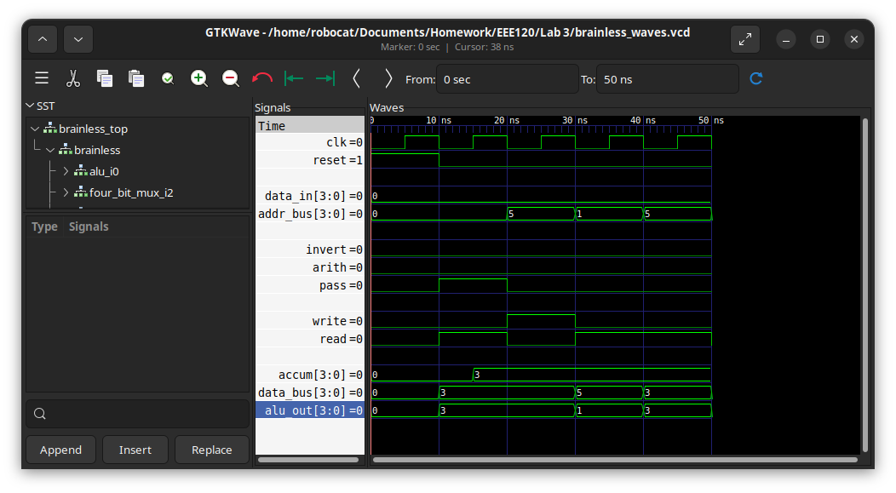
test_vals[0] = 28'h0_0_0_0_0_0_4; // reset - this should always be the first vector
test_vals[1] = 28'h3_3_3_0_0_3_1; // get 3 into the accumulator
test_vals[2] = 28'h3_3_3_0_5_0_A; // Load the three into address 5
test_vals[3] = 28'h3_5_1_0_1_0_1; // Ensure that there is a 5 at address 1
test_vals[4] = 28'h3_3_3_0_5_0_1; // Ensure that there is a 3 at address 5
ALU
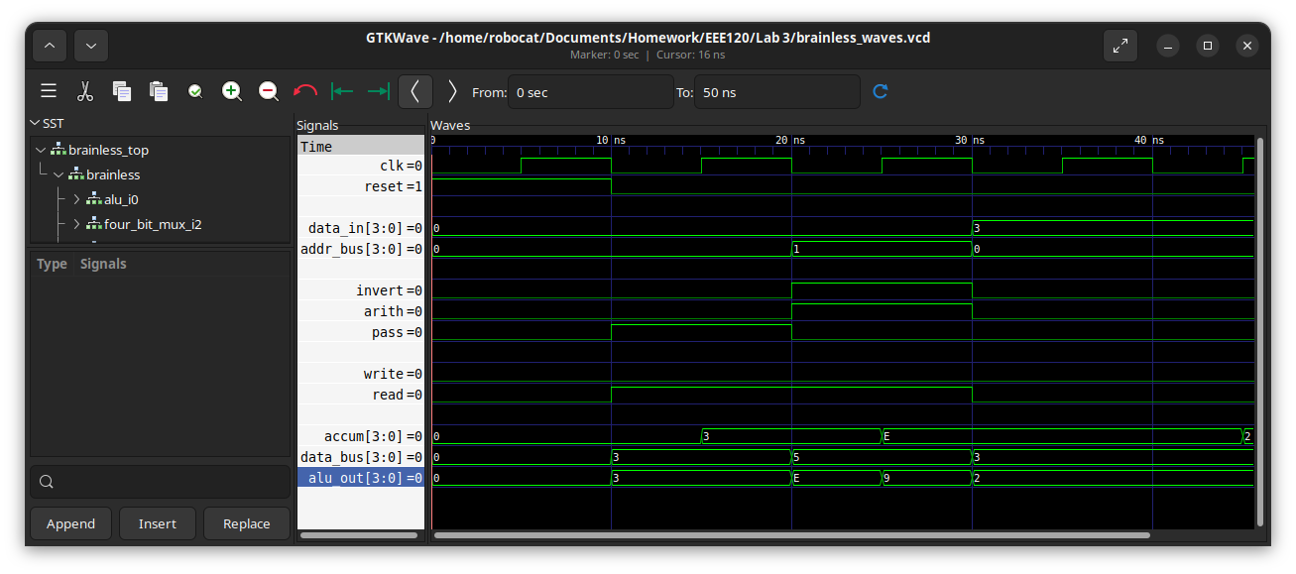
test_vals[0] = 28'h0_0_0_0_0_0_4; // reset - this should always be the first vector
test_vals[1] = 28'h3_3_3_0_0_3_1; // get 3 into the accumulator
test_vals[2] = 28'hE_5_9_0_1_D_1; // subtract 3-5 and store in the accumulator
test_vals[3] = 28'hE_3_2_3_0_0_0; // AND 3 (ext) and accum(E)
test_vals[4] = 28'h2_3_2_3_0_1_0; // Store in the accum
If you changed your circuit since you took the screenshot for Task 3-4, take another and replace the screenshot in Task 3-4.
Include a picture of your GTKWave waveforms here (one per required test):
Please comment on the single biggest issue you were facing when designing the circuit.
I messed up reading how the bits were arranged in the file, and was struggling to figure out why iverilog was getting different results than doing it myself in digital.
Did the circuit behave as expected? If no, what was wrong?
Yes, the circuit behaved as I expected.
Please comment on the single biggest issue you were facing when simulating the circuit.
I kept forgetting to make sure the expected value for the accumulator is correct when I was doing nothing.
Task 3-7: Create a video and submit your report
Record a short video showing your schematics in Digital and your waveforms in GTKWave. Be sure to show yourself in the video and show your screen. Explain how your circuit works – you need to convince the grader you did the lab and understand it! Copy and paste the link to your video below. Make sure the link is working and pointing to the correct video. Remember to include the password if required. Do NOT upload your video to Canvas. It is recommended that you use Zoom to record to the cloud, pasting the link and password below. If your circuit is not working as expected, explain in the video how it is not working and why you think it is not working.
Video Link: https://drive.google.com/file/d/1FSQT5K9qz7wgWv-add_h1DJFbcXOHMfH/view?usp=drive_link
At the beginning of your recording, say your name and the lab name. Be brief in your recording. Submit the completed template to Canvas.
Make sure all your files are in the Lab3 directory. Create a zip file of the Lab3 directory. Remember to turn in the zip file and your completed template on Canvas!
Do not include the video in the zip file! This makes the file very large and you run the risk of the zip file not uploading or taking so long to upload that your submission will be late. Remember that the submission is dated at the time the upload completes, not when it starts!

Lab 3: Lab Report Grade Sheet

Name:

NOTE: You submit the zip file in order to show your work.
If the zip file is not submitted you will receive a 0 for this lab!

Instructor Assessment
Grading Criteria | Max Points | Points Lost
Description of Assigned Tasks, Work Performed & Outcomes Met
Task 3-1: Build and Test a 4-Bit D Register with Enable | 10
Task 3-2: Build and Test a 4-Bit UP Counter | 10
Task 3-4: Build and Test the Brainless Central Processing Unit | 10
Task 3-5: Simulate the Brainless Central Processing Unit | 10
Task 3-6: Create Additional Tests | 10
Task 3-7: Create a video and submit your report | 10
 | Points Lost
Lab Score (60 points total) | Late Lab
 | Lab Score

